Mathematical Modeling:

The Glue That Binds

Introduction

Toward a Deeper Study of Important Mathematics

More than at any other time in history, society is placing demands on citizens to interpret and use mathematics to make sense of information and complex situations. Computers and other technologies have increased our capacities for dealing with numbers for collecting, organizing, representing, and analyzing data. Tables, lists of numbers, graphs of data, and statistics summarizing information occur in every form of the media.

To be well informed as adults and to have access to desirable jobs, students today require an education in mathematics that goes far beyond what was needed by students in the past. All students must develop and sharpen their skills; deepen their understanding of mathematical concepts and processes; and hone their problem-solving, reasoning, and communication abilities while using mathematics to make sense of and to solve compelling problems. All students need a deep understanding of mathematics; for this to occur, rigorous mathematical content must be reorganized, taught, and assessed in a problem-solving environment. For students to develop this deeper level of understanding, their knowledge must be connected to a variety of ideas and skills across topic areas and grade levels in mathematics to other subjects taught in school as well as to situations outside the classroom.

Mathematical Modeling

Mathematical modeling currently has the same cachet as discrete math did in the 1980s. Every book claims to have modeling in it. Many workshops are given about modeling. However, it is rarely defined in precise terms. Phrases such as “we do modeling” and “our book has a modeling component” are everywhere. What do these phrases mean? How do we go about doing modeling and do we need to? This workshop is an attempt to help answer these questions and others. Although it is just a beginning, it will hopefully help you in analyzing textbooks for a modeling component and answering whether you want this in your curriculum.

Much of the confusion about modeling is that different people use different definitions of the term. It is therefore important to be aware of what definition(s) is being used. For the purposes of this talk, we will use the following definitions.

Definition(s):

Model as a noun:

Looking at previously created mathematical models in a variety of areas and applying the model to similar situations.

Using this definition, most of the current (and previous textbooks are able to state that they have a modeling component. An example of this might be giving students an equation for the height of an object as 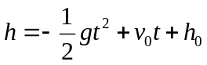, where h is the height, t is the time, h₀ is the initial height, v₀ is the initial velocity, and g is the effect of gravity. Given this equation, and some initial conditions, the student is then asked to evaluate this equation to find the height at given times, or find one of the other values.

Model as a verb:

To use the process of modeling to define and answer a question that is of some interest.

The process of modeling might be defined in the following way

- Identify the problem to be investigated
- Determine the important factors
- Represent those factors and their interplay as in a mathematical way and analyze the mathematical relationships
- Interpret the mathematical results in the context of the real-world phenomenon
- Evaluate how applicable the results are to the real-world situation.
- If necessary, re-examine the factors that were considered and structure of the initial model

Uses of Mathematical Modeling
(Not necessarily mutually exclusive)

As a way to use mathematics previously learned

This could also be where model as a noun is used, depending on how it is introduced. By the very nature of this definition, the particular mathematics must be learned prior to using it on other problems or extensions of the particular model. Consider the following:

Question: How can we create the impression of motion?

- Begin to understand how the appearance of movement is created.
- Create a blinking dot on the calculator screen.
- Create the appearance of moving a dot horizontally across the calculator screen.
- Create the appearance of moving a dot diagonally across the calculator screen.
- Create the appearance of fireworks on the calculator screen.

Below is a calculator program that will “move” a dot horizontally across the screen. The starting location is defined by a combination of the “For(P,0,98,1)” and the “Pt-On(P,20,2)” statements. The P defines the horizontal location (actually 94 pixels wide) and the 20 the vertical location. The value of P runs from 0 to 98 (by 1s) which alters the horizontal value. The velocity of the animation is defined in the “For(Q,1,50,1)”.

Horizontal Motion HLine
prgmAADEFAUL
0➔Xmin:98➔Xmax
0➔Ymin:64➔Ymax
For(P,0,98,1)
Pt-On(P,20,2)
For(Q,1,50,1)
End
Pt-Off(P,20,2)
End

- Vary the velocity and starting location to experiment with the animation.
- Modify the program so that the movement is vertically from the bottom to the top of the screen (screen height is 64 pixels).

There could also be a verb component in this area however. For example, if the context is changed and the students are expected to apply previously learned mathematics to a new situation, it could be considered modeling as a verb. Consider if you have a group of students who have previously worked with recursive definitions of functions and addition of matrices. You then present the problem of how to create the appearance of motion on a calculator screen. As students begin wrestling with this problem, they may first simplify the problem by examining how to move a point across the screen. They might then realize that moving many points might be easier by organizing a set of points in a matrix and then use matrix addition to help define the displacement each frame, as shown in the program MOVEES.
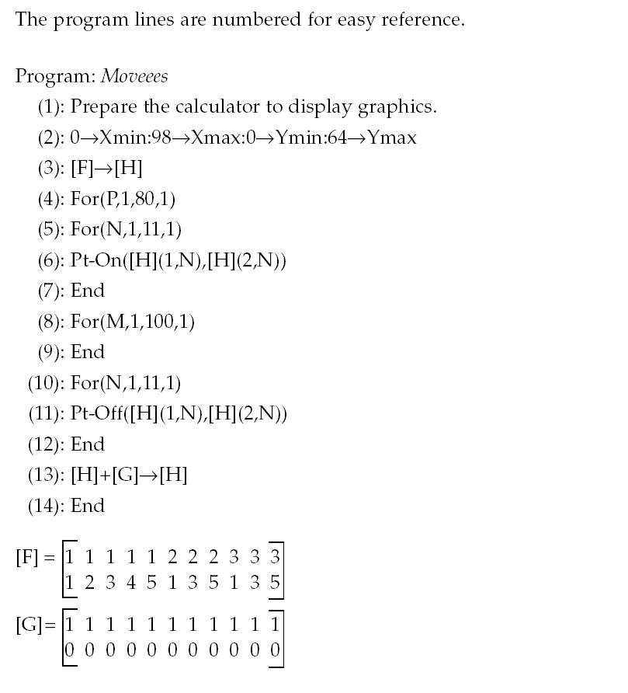
Note: the loop defined in lines 5-7 turns the points on; the lines 10-12 turn them off. Line 13 uses a recursive definition to add the displacement matrix [G] to the matrix that holds the points to display. The loop beginning at 4 and ending at 14, steps through the process 80 times. Once students have built this process and understanding, they could then apply this knowledge to similar figures and/or extend it to more involved animation.

- Create a program that will move your initials across the calculator screen.

- Create a series of programs that will animate a flare firing into the sky and then bursting into a fireworks display.

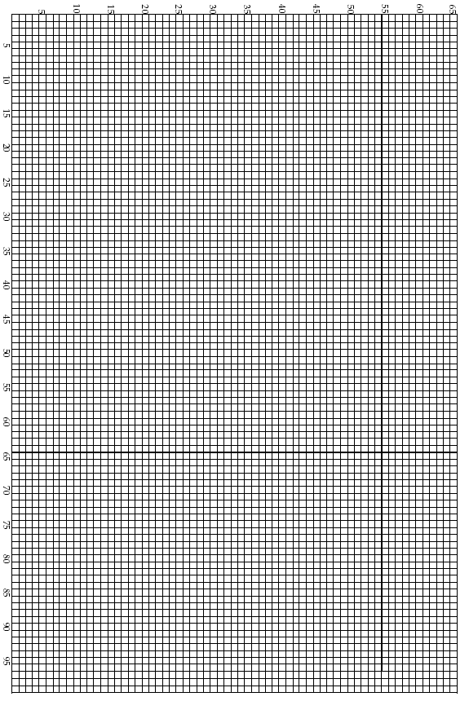

As a way to discover new mathematical relationships:

By its very nature, this would have to use modeling as a verb, since the students would not know the resulting mathematics that is the solution. They would use the mathematics they know as a starting point.

Is it possible to save money on tests if you pool the samples?

This activity will explore how different probability rates affect the expected number of tests required.
When prompted by the calculator program, give it the probability (decimal, please!), and set the number of trials to be 1000. Settle in for a couple of minutes; after the calculator has done all those trials, record your results in the table below and share them with other groups according to directions given. In the tables below, record the class results for the average number of tests needed for 1000 trials in the space below the appropriate probability of occurrence:

Probability (p) | 0.0 | 0.1 | 0.2 | 0.3 | 0.4 | 0.5 | 0.6 | 0.7 | 0.8 | 0.9 | 1.0
Avg. No. of Tests (E)

- Using the data collected, make a graph of Expected Value (E) vs. probability (p).
- In creating a model, the first clue is the pattern showing up in the scatterplot. Describe the graph - what kind of pattern seems to relate these quantities?
- You may have answered the previous question by saying that the pattern looks linear. Let’s assume that it is. The next step is to describe the pattern in mathematical terms.
  - Draw a line that starts at the first point (0,1), and goes to the last point (1,3). Find the slope of that line.
  - Write the equation for the line in slope-intercept form; this will be our first model for these data.

- Now, we have to see how good a job our model does in describing the actual data. Fill in the table below; the actual values are the ones found from the simulation and recorded on the previous page. The equation above tries to “predict” these data, and so predicted values are found by taking each value for the probability and using it in the equation you just derived. Finally, errors (residuals) are how far the predictions are from the actual data, so they are found by subtraction: errors = observed – expected.
Probability (p) | Observed Value (E) | Expected Value | Error (residual)
0.0
0.1
0.2
0.3
0.4
0.5
0.6
0.7
0.8
0.9
1.0

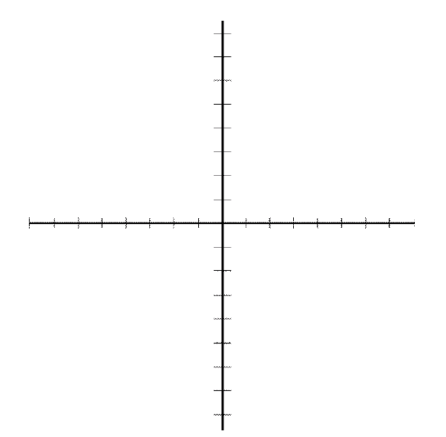
- Finally, make a graph of errors vs. probability (p).
- A good model will show a random pattern of residuals, with a balance of points above and below the zero line. Does the model you’ve developed have those properties?
Students would then continue and realize that this graph is a shape they have not seen before. They will then continue on to find a “new” relationship. While this isn’t modeling in the strictest sense, it uses the processes of modeling to find and examine this relationship.

As a way to connect mathematics to the world

All of the samples presented above and below would satisfy this use.

As a way to stretch students problem solving skills

If you really wish to have students use mathematical modeling as a completely open-ended process, you will not be able to predict what mathematics they might use or discover. The two examples below are taken from the High School Modeling Contest in Mathematics. These are very open-ended and do not anticipate any particular mathematical approach.

Skyscrapers
Skyscrapers vary in height, size (square footage), occupancy rates, and usage. They adorn the skyline of our major cities. But as we have seen several times in history, the height of the building might preclude escape during a catastrophe either human or natural (earthquake, tornado, hurricane, etc). Let's consider the following scenario. A building (a skyscraper) needs to be evacuated. Power has been lost so the elevator banks are inoperative except for use by firefighters and rescue personnel with special keys.
Build a mathematical model to clear the building within x minutes. Use this mathematical model to state the height of the building, maximum occupation, and type of evacuation methods used. Solve your model for x = 15 minutes, 30 minutes, and 60 minutes.

Adolescent Pregnancy

You are working temporarily for the Department of Health and Environmental Control. The director is concerned about the issue of teenage pregnancy in their region. You have decided that your team will analyze the situation and determine if it is really a problem in this region. You gather the following 2000 data.

 | Pregnant |  |  | Births |  |  | Births - unmarried
Age | 10-14 | 15-17 | 18- 19 | 10-14 | 15-17 | 18-19 | 10-14- | 15-17 | 18-19-
County
1 | 29 | 350 | 571 | 17 | 281 | 437 | 16 | 164 | 193
2 | 24 | 303 | 567 | 13 | 206 | 466 | 13 | 151 | 233
3 | 40 | 422 | 691 | 29 | 307 | 546 | 28 | 251 | 366
4 | 21 | 201 | 356 | 18 | 184 | 326 | 15 | 137 | 180
5 | 16 | 156 | 357 | 11 | 109 | 254 | 10 | 99 | 161
6 | 44 | 523 | 970 | 33 | 442 | 803 | 32 | 293 | 396
7 | 17 | 263 | 434 | 9 | 201 | 345 | 7 | 113 | 168
8 | 23 | 330 | 427 | 16 | 256 | 444 | 14 | 160 | 210
9 | 13 | 123 | 221 | 10 | 113 | 199 | 9 | 78 | 106
10 | 41 | 467 | 950 | 24 | 446 | 686 | 22 | 279 | 331
11 | 28 | 421 | 713 | 18 | 343 | 615 | 15 | 219 | 328
12 | 9 | 179 | 311 | 8 | 145 | 261 | 7 | 114 | 162

1998
Age | Pregnancies | Births
10-14 | 320 | 231
15-17 | 4041 | 3222
18-19 | 6387 | 5164

1999
Age | Pregnancies | Births
10-14 | 309 | 208
15-17 | 3882 | 3048
18-19 | 6714 | 5391

Build a mathematical model and use it to determine if there is a problem or not. Prepare an article for the newspaper that highlights your result in a novel mathematical relationship or comparison that will capture the attention of the youth.

Now that we have a common understanding of what I mean by modeling, lets examine whether it is something you wish to include in your curriculum. What are the benefits and drawbacks? Since time is limited I will just list what I feel are the strengths and weaknesses of modeling – you can certainly find more. I leave it to you to discuss with your colleagues whether you feel the strengths outweigh the weaknesses.

Strengths

Interest
There is little doubt that most students will be more interested in a modeling problem than solving an equation or using an application that doesn’t necessarily connect to their world. Of course, there are always some students (like us) who find equations interesting for themselves, but the majority of students will be more engaged if they can tie these to a real-world event or problem.

Connections
It becomes quite easy to make connections to other situations and problems.

Transfer
It is much easier for most students to remember a modeling problem than an equation. Once they relate the commonality of one situation to another, they can apply the mathematics to the new situation.

Residue
Most students will remember a problem that they have spent quality time on rather than a mathematical characteristic.

Flexibility

When using the modeling process it is quite possible to control how far you have the students go with it and to gauge the sophistication level of the students and to vary the problem for individuals or groups of students.

Writing, Reading, and Thinking

There can be little argument that modeling requires much more reading, writing, and in most cases, thinking, than does a standard example>practice process. The responses require much more than just “show your work”.

Weaknesses

Time
Most modeling problems will take more time than a traditional chapter in a textbook. It will take time to understand the context as well as what problems need to be considered.

Finding Good Problems
If you are looking in papers, magazines, and other journals, many times the flow and deepness of the process is compromised. A problem that you think looks interesting might not yield a problem that works well in the classroom.

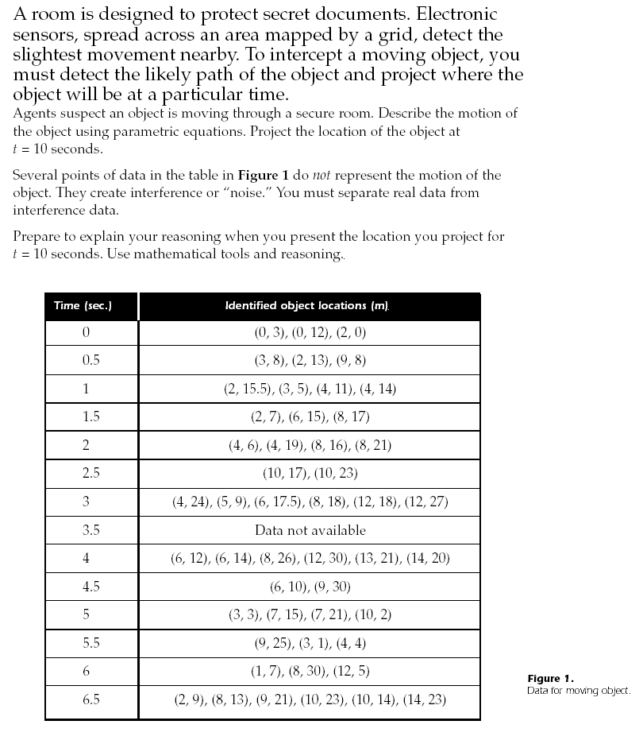


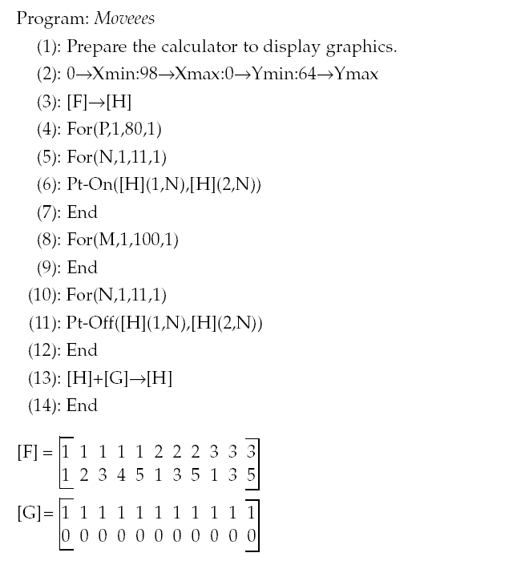

Definitions

Model as a noun:

Looking at previously created mathematical models in a variety of areas and applying the model to similar situations.

Model as a verb:

To use the process of modeling to define and answer a question that is of some interest.

The Process of
Mathematical Modeling

- Identify the problem to be investigated
- Determine the important factors
- Represent those factors and their interplay as in a mathematical way and analyze the mathematical relationships
- Interpret the mathematical results in the context of the real-world phenomenon
- Evaluate how applicable the results are to the real-world situation.
- If necessary, re-examine the factors that were considered and structure of the initial model

Mathematical Modeling

Real-World
Situation
Mathematical Model
Analyze

Translate

Analyze
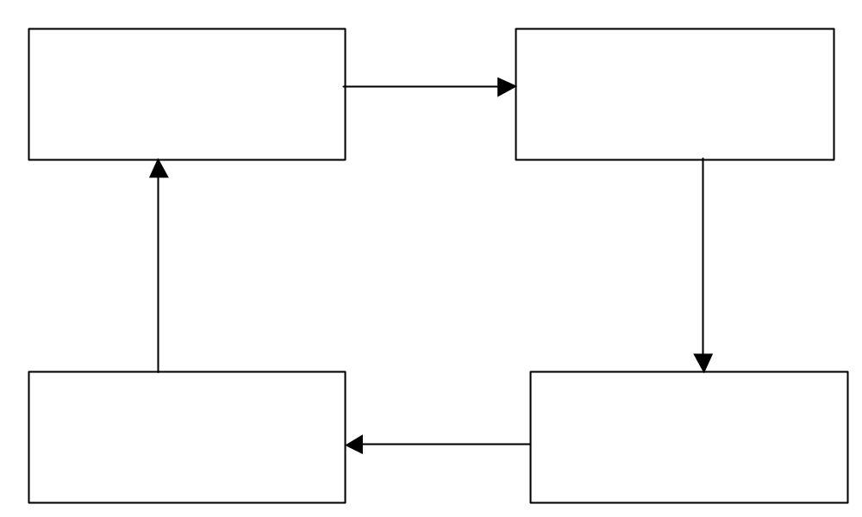
Real-World Conclusions or Predictions
Mathematical Conclusions

Translate
Uses of Mathematical Modeling
As a way to:

- Reinforce mathematics previously learned
- Discover new mathematical relationships
- Connect mathematics to the world
- Stretch students’ problem solving skills
- Link mathematics to other disciplines

Science Social Studies
Language Arts Visual and Performing Arts

Strengths

Interest
There is little doubt that most students will be more interested in a modeling problem than solving an equation or using an application that doesn’t necessarily connect to their world. Of course, there are always some students (like us) who find equations interesting for themselves, but the majority of students will be more engaged if they can tie these to a real-world event or problem.

Connections
It becomes quite easy to make connections to other situations and problems.

Transfer
It is much easier for most students to remember a modeling problem than an equation. Once they relate the commonality of one situation to another, they can apply the mathematics to the new situation.

Residue
Most students seem to remember a problem that they have spent quality time on rather than a mathematical characteristic.

Flexibility

When using the modeling process it is quite possible to control how far you have the students go with it and to gauge the sophistication level of the students and to vary the problem for individuals or groups of students.

Writing, Reading, and Thinking

There can be little argument that modeling requires much more reading, writing, and in most cases, thinking, than does a standard example → practice process. The responses require much more than just “show your work”.

Weaknesses

Time

Most modeling problems will take more time than a traditional chapter in a textbook. It will take time to understand the context as well as what problems need to be considered.

Finding Good Problems

If you are looking in papers, magazines, and other journals, many times the flow and richness of the process is compromised. A problem that you think looks interesting might not yield a problem that works well in the classroom.

Guaranteeing Mathematics

If you are not careful with your selection of problems, you may get some that yield little or no significant mathematics or that may require more sophisticated mathematics than the students can handle at the time.

HiMCM

The High School Mathematical Contest in Modeling

November 1-18, 2002
http://www.comap.com/highschool/contests/himcm/index.html

The High School Mathematical Contest in Modeling (HiMCM) was designed to:

- Provide students with the opportunity to work as team members in a contest.

- Stimulate and improve their problem solving and writing skills.

Teams

- consist of up to four students
- work on a real-world problem for a consecutive thirty-six hour period.
- are allowed to work on the contest problem at any available facility
- submit their solution papers to COMAP for centralized judging.

- To participate in HiMCM a team must be sponsored by a faculty advisor from that school.

- The registration process must be completed by the advisor.

Question: How can we create the impression of motion?

- Begin to understand how the appearance of movement is created.
- Create a calculator program that will place a dot in the middle of the screen and have the dot blink on and off.
- Create a calculator program that will “move” a dot horizontally across the screen.
- Create a calculator program that will “move” a letter horizontally across the screen.
- Create a calculator program that will create the impression of a flare being shot into the sky.
- Create a calculator program that will create the impression of a fireworks display.

Standards Addressed
1.5 Understand and apply concepts and procedures from algebraic sense, including relations and representations, and operations
2.1 Investigate situations by searching for patterns and exploring a variety of approaches
2.2 Formulate questions and define the problem
2.3 Construct solutions by choosing the necessary information and using the appropriate mathematical tools
4.2 Organize and interpret information
4.3 Represent and share information; share, explain, and defend mathematical ideas using terms, language, charts, and graphs that can be clearly understood by a variety of audiences
5.3 Relate mathematical concepts and procedures to real-life situations; understand the connections between mathematics and problem-solving skills used every day at work and at home

Mathematical content
Coordinate systems  Variables and constants  Recursive and closed-form representations | Rates of change  Matrix representations and addition  Parametric equations | Elementary programming  Graphs  Systems of linear equations  Linear functions

The Living Marquee

Get in a line (shoulder-shoulder) with all people facing the same way.
Using your motion cards, create a “moving” dot.
Do the same simulation with your eyes closed.
What is the rate of change of your living marquee? (persons/second)
Demonstrate the motion to the other groups.

How did you decide when to turn your card when:

Your eyes were open?
Your eyes were closed?

Three different rates of change are commonly used in animation.
The number of times the animation changes frames in a second (frames per second).
The number of pixels that change in each frame (pixels per frame).
The speed at which the dot appears to move (pixels per second).

Below is a calculator program that will “move” a dot horizontally across the screen. The starting location is defined by a combination of the “For(P,0,98,1)” and the “Pt-On(P,20,2)” statements. The P defines the horizontal location (actually 94 pixels wide) and the 20 the vertical location. The value of P runs from 0 to 98 (by 1s) which alters the horizontal value. The velocity of the animation is defined in the “For(Q,1,50,1)”.

Horizontal Motion HLine
prgmAADEFAUL
0➔Xmin:98➔Xmax
0➔Ymin:64➔Ymax
For(P,0,98,1)
Pt-On(P,20,2)
For(Q,1,50,1)
End
Pt-Off(P,20,2)
End

- Vary the velocity and starting location to experiment with the animation.
- Modify the program so that the movement is vertically from the bottom to the top of the screen (screen height is 64 pixels).

- Create a calculator program that will “move” the letter E horizontally across the screen. You can use the grid paper at the back of this document to assist you.

Note: If you are going to use a large portion of another program and don’t want to re-enter all the lines, you can use the RCL key to copy the entire program into the new one. To do this:
Create the name for the new program (PRGM, NEW, Name it)
RCL (shift STO key)
PRGM
Exec
Select the program you want to copy (either by number or cursor).



Blinking Dot | Horizontal Motion
Blinker  prgmAADEFAUL  0➔Xmin:98➔Xmax  0➔Ymin:64➔Ymax  For(H,1,50,1)  Pt-On(30,20,2)  For(T,1,50,1)  End  Pt-Off(30,20,2)  For(T,1,50,1)  End  End | HLine  prgmAADEFAUL  0➔Xmin:98➔Xmax  0➔Ymin:64➔Ymax  For(P,0,98,1)  Pt-On(P,20,2)  For(Q,1,50,1)  End  Pt-Off(P,20,2)  End
Moving E (recursive) | Moving E
Emotion  prgmAADEFAUL  0➔Xmin:98➔Xmax:0➔Ymin:64➔Ymax  [[1,1,1,1,1,2,2,2,3,3,3][1,2,3,4,5,1,3,5,1,3,5]] ➔ [F]  [[1,1,1,1,1,1,1,1,1,1,1][0,0,0,0,0,0,0,0,0,0,0]] ➔ [G]  [F] ➔ [H]  For(P,1,80,1)  For(N,1,11,1)  Pt-On([H](1,N),[H](2,N))  End  For(M,1,100,1):End  For(N,1,11,1)  Pt-Off([H](1,N),[H](2,N))  End  [H]+[G] ➔ [H]  End | Eeoption  prgmAADEFAUL  0➔Xmin:98➔Xmax:0➔Ymin:64➔Ymax  [[1,1,1,1,1,2,2,2,3,3,3][1,2,3,4,5,1,3,5,1,3,5]] ➔ [F]  For(P,0,80,1)  For(N,1,11,1)  [F](1,N) ➔H  [F](2,N) ➔V  Pt-On(H+P,V)  End  For(M,1,100,1):End  For(N,1,11,1)  [F](1,N) ➔H  [F](2,N) ➔V  Pt-Off(H+P,V)  End  End
Diagonal | AADEFAUL
prgmAADEFAUL  0➔Xmin:98➔Xmax:0➔Ymin:64➔Ymax For(P,0,60,1)  1.5P➔H  P➔V  Pt-On(H,V,2)  For(T,1,50,1)  End  Pt-Off(H,V,2)  End | Float  Radian  Func  Connected  Sequential  Full  RectGC  CoordOn  GridOff  AxesOff  LabelOff  PlotsOff  FnOff  Zstandard  ClrHome  ClrDraw

Adapted from the OSPI website: http://www.k12.wa.us/curriculuminstruct/math/default.asp
From Mathematics: Modeling Our World, Book 1
From Mathematics: Modeling Our World, Book 1
From the HiMCM 2001
From the HiMCM 2001

