UW Math Circle

Math Auction

11 December 2014

Each problem is worth ʕ100.
- Call an English word alternating if another word is formed by reading every other letter in the word, starting with the first. (For example, “theorem” is an alternating word because “term” is a word.) Find as many alternating words as possible.
- Find the longest arithmetic sequence consisting of numbers that are not prime and less than 2014, with the condition that the greatest common divisor of all the numbers is 1. (For example, (1, 125, 249) is such a sequence, but (6, 10, 14, 18) is not because all of the numbers are divisible by 2.)
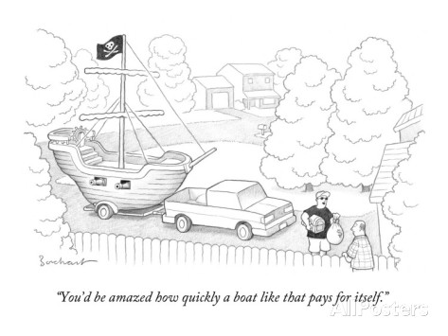
- One 6×1 aircraft carrier, two 5×1 battleships, three 4×1 destroyers, four 3×1 cruisers, five 2×1 submarines, and six 1×1 lifeboats are to be stationed in a grid for navy exercises. Find the smallest square grid that will fit the entire 21-ship fleet if the ships are not allowed to touch, even at corners.
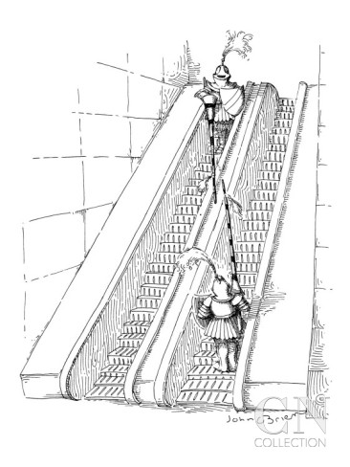
- Place as few knights as possible on a chessboard so that every square on the board is under attack (including the squares occupied by knights).
- Write an expression equaling 2014 using only one-digit numbers, the operations of subtraction and division, and parentheses. Use as few digits as possible.
- The following 3×3 grid contains eight Whozits – five red, three blue. The center square is empty. Slide the Whozits orthogonally around the grid into a position where no two adjacent Whozits are the same color. Use as few moves as possible. (One move is counted when a single Whozit slides up, down, left, or right by one square.)
