- You have 15 animals. Some are tigers and some are dragons. You have 157 heads of broccoli. Each dragon gets 10 heads of broccoli and each tiger gets 11. How many tigers and how many dragons are there?
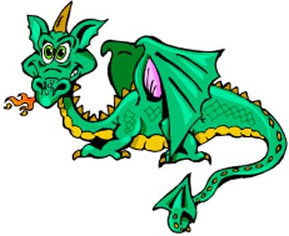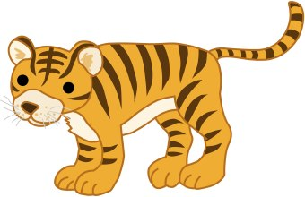

Challenge
- A certain pet shop sells large birds and small birds; each large bird fetches twice the price of a small one. A lady came in and purchased five large birds and three small ones. If, instead, she had bought three large birds and five small birds, she would have spent $20 less. What is the price of each bird?
